EduLedger Frontend Review

1. Home Page
- UI needs refinement to better match the Figma.
- Hero section, cards, "How It Works", "Top Authors", and footer require improvements.
- Typography, spacing, icons, responsiveness, and overall visual polish need updates.
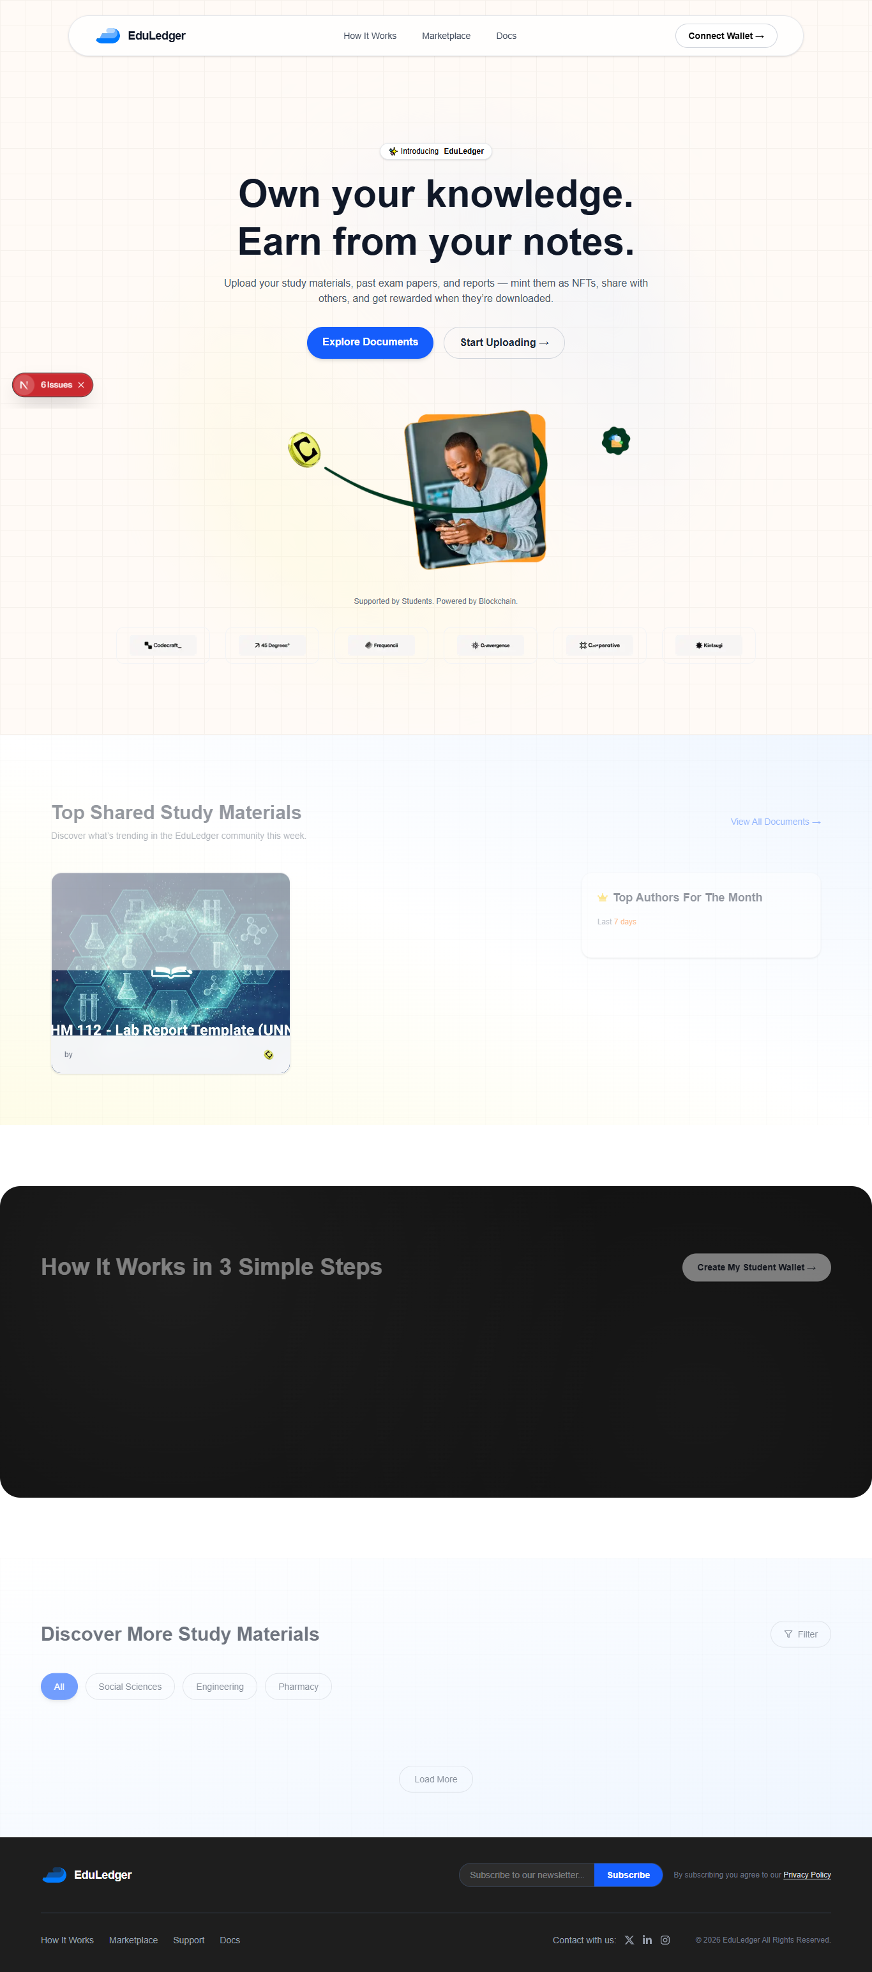

2. Marketplace Page
- Banner, categories sidebar, and filters need to match the Figma.
- Card design, typography, spacing, buttons, and icons require refinement.
- Expand/collapse category icons are missing.
- Pagination needs to be fixed.
- Overall UI requires polishing and responsiveness improvements.
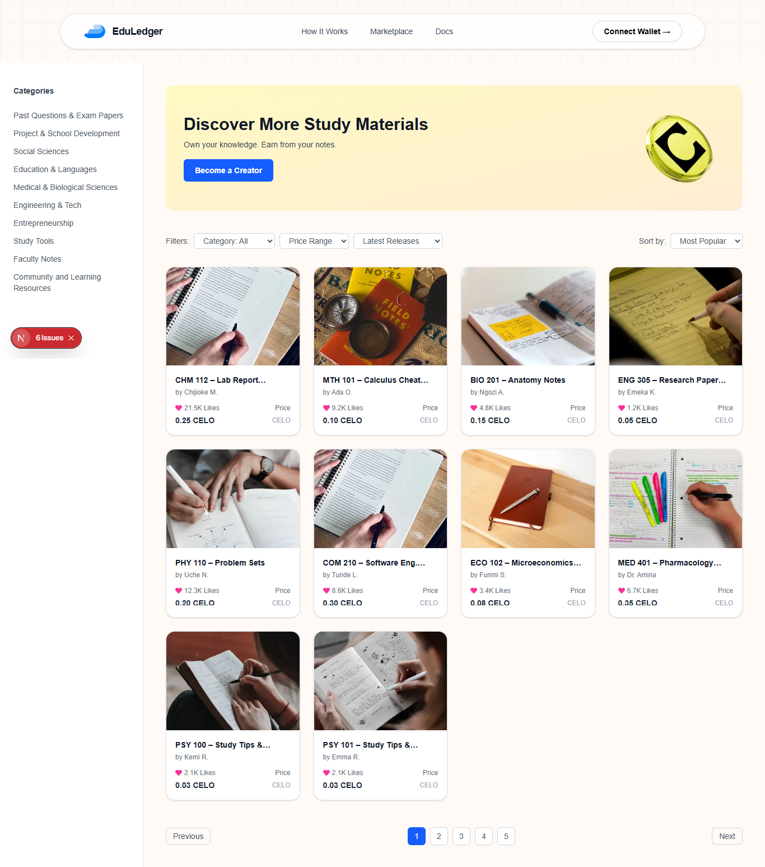

3. Note Details Page
- Layout, spacing, typography, buttons, and cards need refinement.
- "Discover More Notes" section should better match the Figma.
- Previous/Next navigation is missing.
- Footer, icons, and overall UI polish require improvements.
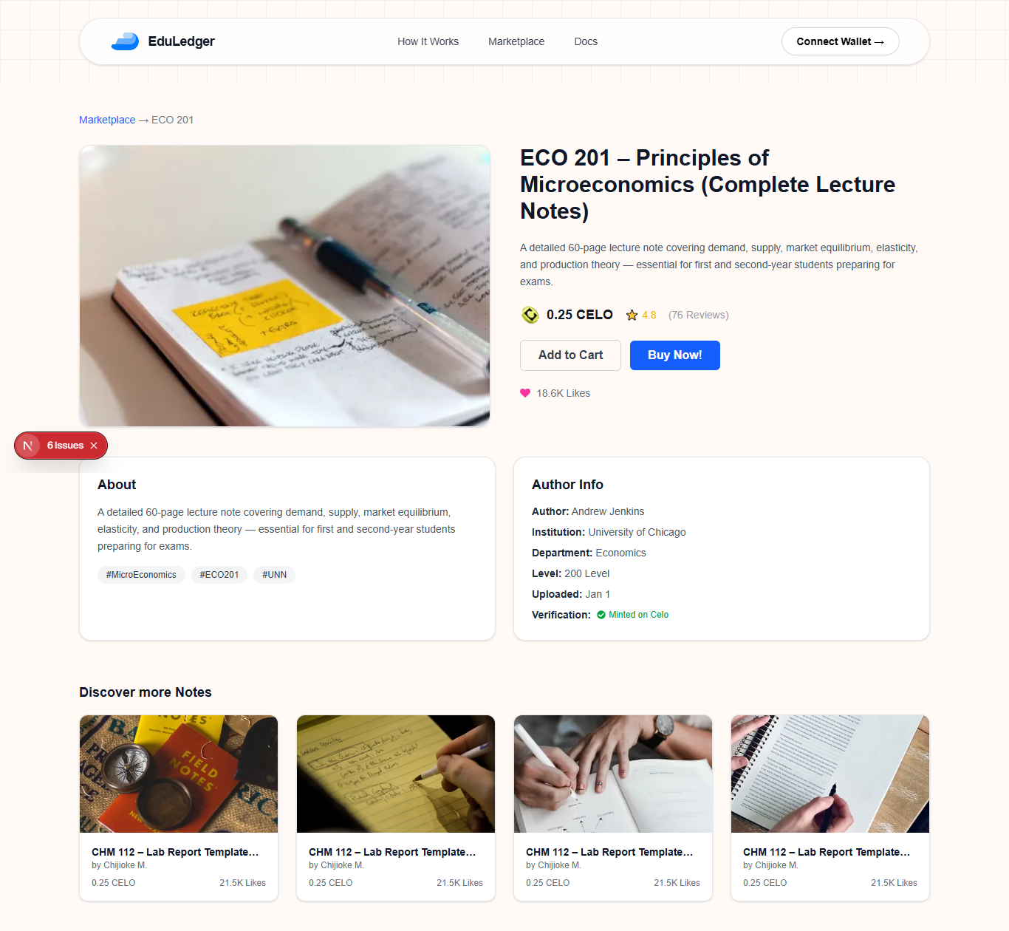

4. Connect Existing Wallet, Connect New Wallet
- UI requires refinement to match the Figma.
- Wallet connection flow needs verification.
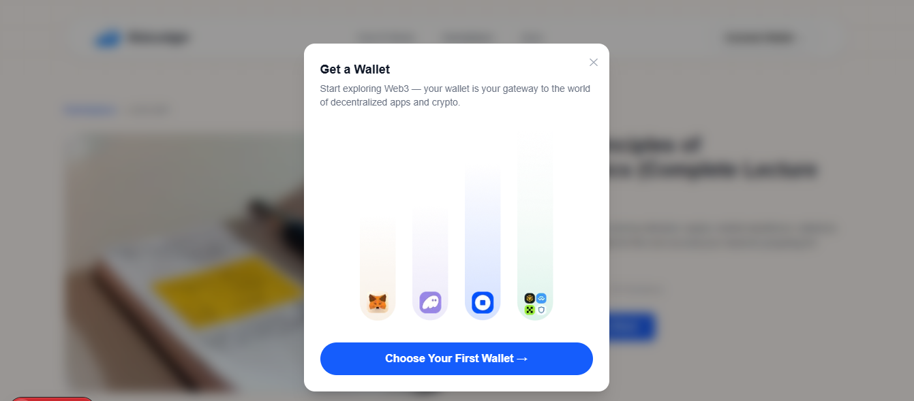
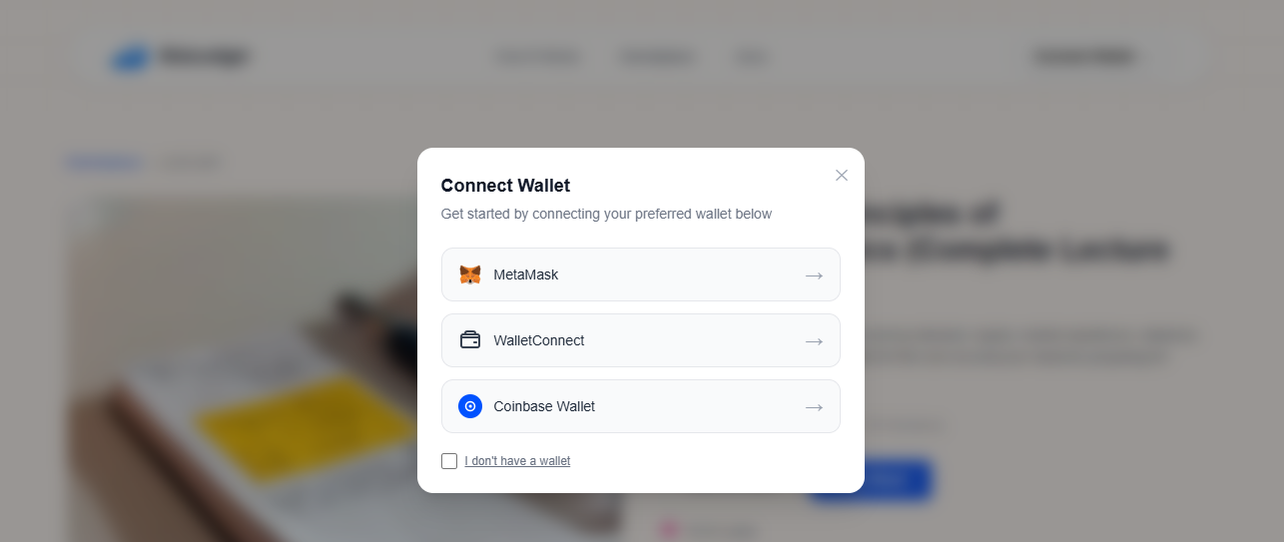

5. Authentication Screens (Not Implemented)
The following Figma screens are currently missing:
- Login
- Sign Up
- Account Created (Success)

6. Dashboard
- Dashboard UI components exist in the codebase.
- However, the dashboard is currently not accessible through the application flow.
- Navigating to the dashboard redirects back to the Home page.
- Dashboard Empty State screen from the Figma is missing.
- Dashboard Wallet Connected state requires verification and integration.

7. Remaining Screens to Implement
The following screens/pages are either missing or not accessible:
- Upload Note
- Upload New Notes
- Mint NFT
- Success Confirmation
- Leaderboard
- My Notes
- Edit Note
- Success Confirmation
- My Cart
- History
- Settings

8. Overall Assessment
I have reviewed the current frontend implementation and compared it with the Figma.
Overall, the project has a good foundation, and the core structure is already in place. Several key pages have been implemented; however, additional work is required to match the Figma design more closely and complete the remaining user flows.
I wasn't able to fully verify the wallet integration in my local environment.
Based on my review to complete the remaining frontend work, assuming the backend APIs and smart contracts are ready.

Summary
- The core application structure is in place.
- Home, Marketplace, Note Details, and the Email Modal have been implemented but require UI refinements to match the Figma.
- Several screens are still pending implementation (Authentication, Dashboard flows, Upload, Mint NFT, Leaderboard, My Notes, Cart, History, Settings, etc.).
- Existing pages require improvements in layout, spacing, typography, icons, components, responsiveness, animations, and overall visual polish.
- Routing, authentication flow, wallet flow, and the complete end-to-end user journey should be reviewed and verified before the frontend can be considered production-ready.
- Wallet connection flow has been implemented in the codebase. However, end-to-end testing and verification of the complete wallet flow (connection, authentication, profile creation, and blockchain interactions) are still required.S
- Question: Are all backend APIs ready for frontend integration, or are there still APIs pending to be developed?

Estimated Time: 1 Month

